leonav@leo:~/Documents/Study/Masters/TU Berlin/SS17/Cloud Computing/Open Stack$ openstack image list
Missing value auth-url required for auth plugin password
leonav@leo:~/Documents/Study/Masters/TU Berlin/SS17/Cloud Computing/Open Stack$ export | grep OS_
leonav@leo:~/Documents/Study/Masters/TU Berlin/SS17/Cloud Computing/Open Stack$ source cc17
cc17g2os.key cc17g2os.pub cc17-group02-openrc.sh
leonav@leo:~/Documents/Study/Masters/TU Berlin/SS17/Cloud Computing/Open Stack$ source cc17-group02-openrc.sh
Please enter your OpenStack Password:
leonav@leo:~/Documents/Study/Masters/TU Berlin/SS17/Cloud Computing/Open Stack$ openstack image list
+----------------------------------+--------------------------------+--------+
| ID | Name | Status |
+----------------------------------+--------------------------------+--------+
| 77c18cca-2971-4cc0-b385-e2186e26 | CC17 Group2 Openstack Instance | active |
| 2813 | | |
| 69ca7dc6-51d9-43e1-bee4-68844498 | cirros | active |
| e202 | | |
| bc54114b-9fea-43af-81fd- | ubuntu-14-04 | active |
| ba449f29b766 | | |
| 11f6b8aa-31df-4b66-8b42-5ee9760c | ubuntu-16.04 | active |
| 47ba | | |
+----------------------------------+--------------------------------+--------+
leonav@leo:~/Documents/Study/Masters/TU Berlin/SS17/Cloud Computing/Open Stack$ openstack flavor list
+-------------+-------------+-----+------+-----------+-------+-----------+
| ID | Name | RAM | Disk | Ephemeral | VCPUs | Is Public |
+-------------+-------------+-----+------+-----------+-------+-----------+
| 604de11c-32 | Cloud | 512 | 10 | 0 | 1 | False |
| 22-4902-852 | Computing | | | | | |
| 3-11cc61b5b | | | | | | |
| 485 | | | | | | |
+-------------+-------------+-----+------+-----------+-------+-----------+
leonav@leo:~/Documents/Study/Masters/TU Berlin/SS17/Cloud Computing/Open Stack$ openstack security group list
+----------------------+---------+----------------------+----------------------+
| ID | Name | Description | Project |
+----------------------+---------+----------------------+----------------------+
| a87e65e1-f959-4255-9 | default | Default security | 4894c882bfcc4558ab51 |
| b40-cafe1d9db47c | | group | 5cdc55b32446 |
+----------------------+---------+----------------------+----------------------+
leonav@leo:~/Documents/Study/Masters/TU Berlin/SS17/Cloud Computing/Open Stack$ openstack keypair list
+-----------+-------------------------------------------------+
| Name | Fingerprint |
+-----------+-------------------------------------------------+
| cc17g2os | 70:e5:87:c8:33:40:47:e5:99:f8:5f:de:2d:e2:0f:06 |
| cc17g2ssh | 28:d7:ad:56:3e:e5:90:f4:f6:ed:9a:3b:ba:c1:9f:e3 |
+-----------+-------------------------------------------------+
leonav@leo:~/Documents/Study/Masters/TU Berlin/SS17/Cloud Computing/Open Stack$ openstack server create --flavor FLAVOR_ID --image IMAGE_ID --key-name KEY_NAME \
> --user-data USER_DATA_FILE --security-group SEC_GROUP_NAME --property KEY=VALUE \
> openstack keypair list^C
leonav@leo:~/Documents/Study/Masters/TU Berlin/SS17/Cloud Computing/Open Stack$ openstack server create --flavor FLAVOR_ID --image IMAGE_ID --key-name KEY_NAME --user-data USER_DATA_FILE --security-group SEC_GROUP_NAME --property KEY=VALUE \^C
leonav@leo:~/Documents/Study/Masters/TU Berlin/SS17/Cloud Computing/Open Stack$ openstack server create --flavor FLAVOR_ID --image IMAGE_ID --key-name KEY_NAME \--user-data USER_DATA_FILE --security-group SEC_GROUP_NAME --property KEY=VALUE \INSTANCE_NAME^C
leonav@leo:~/Documents/Study/Masters/TU Berlin/SS17/Cloud Computing/Open Stack$ openstack server create --flavor 604de11c-3222-4902-8523-11cc61b5b485 --image 11f6b8aa-31df-4b66-8b42-5ee9760c47ba --key-name cc17g2os --user-data cloudinit.file --security-group default CC17GROUP2
Can't open 'cloudinit.file': [Errno 2] No such file or directory: 'cloudinit.file'
leonav@leo:~/Documents/Study/Masters/TU Berlin/SS17/Cloud Computing/Open Stack$ openstack server create --flavor 604de11c-3222-4902-8523-11cc61b5b485 --image 11f6b8aa-31df-4b66-8b42-5ee9760c47ba --key-name cc17g2os --security-group default CC17GROUP2
+-----------------------------+--------------------------------------------------------+
| Field | Value |
+-----------------------------+--------------------------------------------------------+
| OS-DCF:diskConfig | MANUAL |
| OS-EXT-AZ:availability_zone | |
| OS-EXT-STS:power_state | NOSTATE |
| OS-EXT-STS:task_state | scheduling |
| OS-EXT-STS:vm_state | building |
| OS-SRV-USG:launched_at | None |
| OS-SRV-USG:terminated_at | None |
| accessIPv4 | |
| accessIPv6 | |
| addresses | |
| adminPass | ZCDZzpw8j5DA |
| config_drive | |
| created | 2017-06-08T12:23:12Z |
| flavor | Cloud Computing (604de11c-3222-4902-8523-11cc61b5b485) |
| hostId | |
| id | cf8c64f0-2917-449c-97cd-ffade0875ae9 |
| image | ubuntu-16.04 (11f6b8aa-31df-4b66-8b42-5ee9760c47ba) |
| key_name | cc17g2os |
| name | CC17GROUP2 |
| progress | 0 |
| project_id | 4894c882bfcc4558ab515cdc55b32446 |
| properties | |
| security_groups | name='default' |
| status | BUILD |
| updated | 2017-06-08T12:23:13Z |
| user_id | 15e8e0d4ac9c4909b90f9f2c4f0994f2 |
| volumes_attached | |
+-----------------------------+--------------------------------------------------------+
leonav@leo:~/Documents/Study/Masters/TU Berlin/SS17/Cloud Computing/Open Stack$

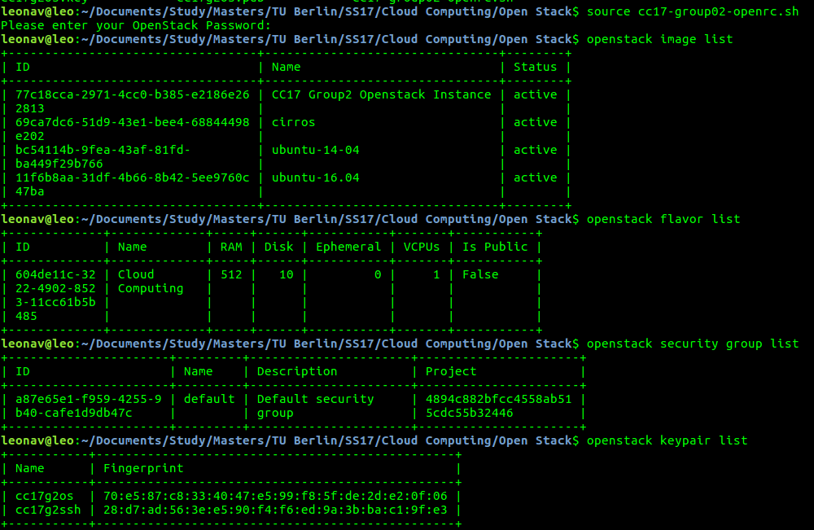

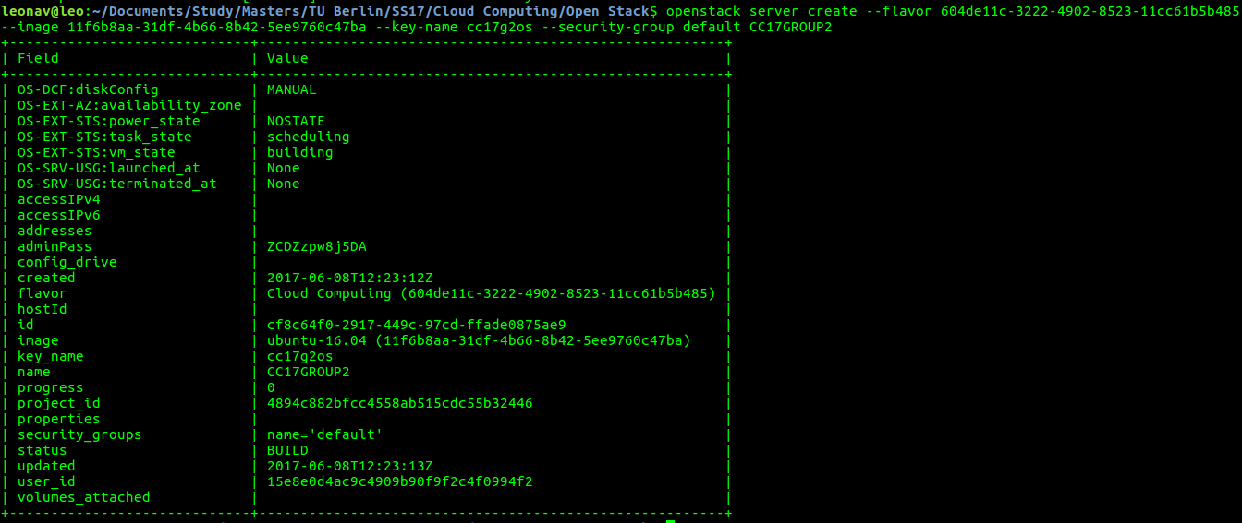
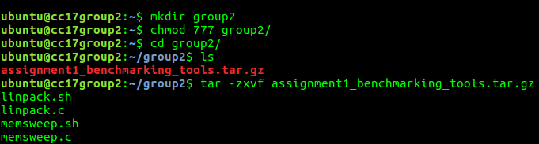
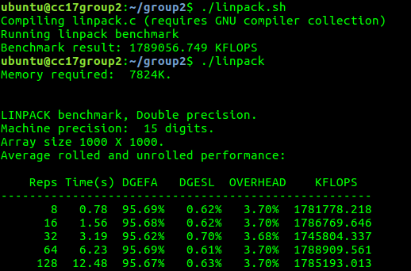
ubuntu@cc17group2:~/group2$ ./linpack
Memory required: 7824K.

LINPACK benchmark, Double precision.
Machine precision: 15 digits.
Array size 1000 X 1000.
Average rolled and unrolled performance:

Reps Time(s) DGEFA DGESL OVERHEAD KFLOPS
----------------------------------------------------
8 0.78 95.69% 0.62% 3.70% 1781778.218
16 1.56 95.68% 0.62% 3.70% 1786769.646
32 3.19 95.62% 0.70% 3.68% 1745804.337
64 6.23 95.69% 0.61% 3.70% 1788909.561
128 12.48 95.67% 0.63% 3.70% 1785193.013

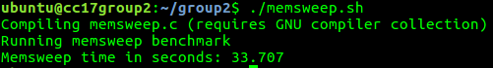

ubuntu@cc17group2:~/group2$ ./memsweep.sh
Compiling memsweep.c (requires GNU compiler collection)
Running memsweep benchmark
Memsweep time in seconds: 33.707

